TC-CSC-007
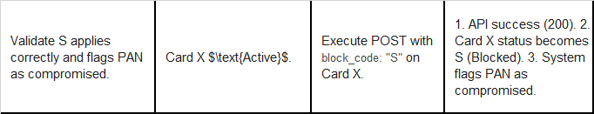
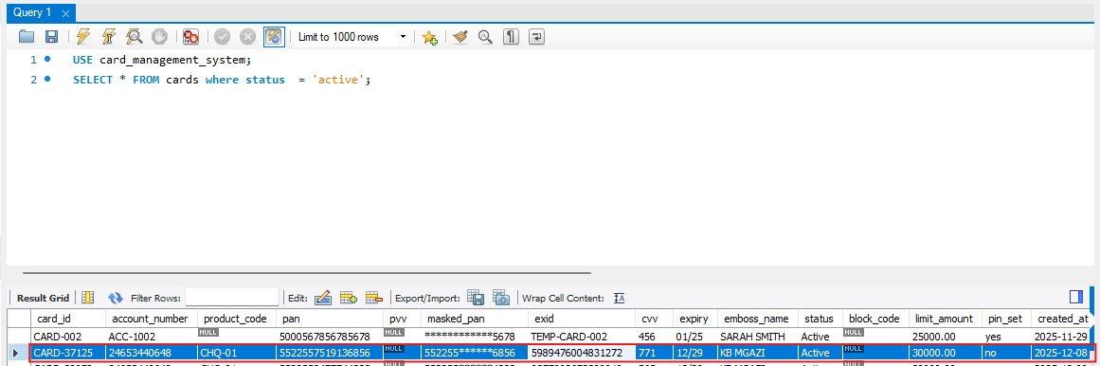
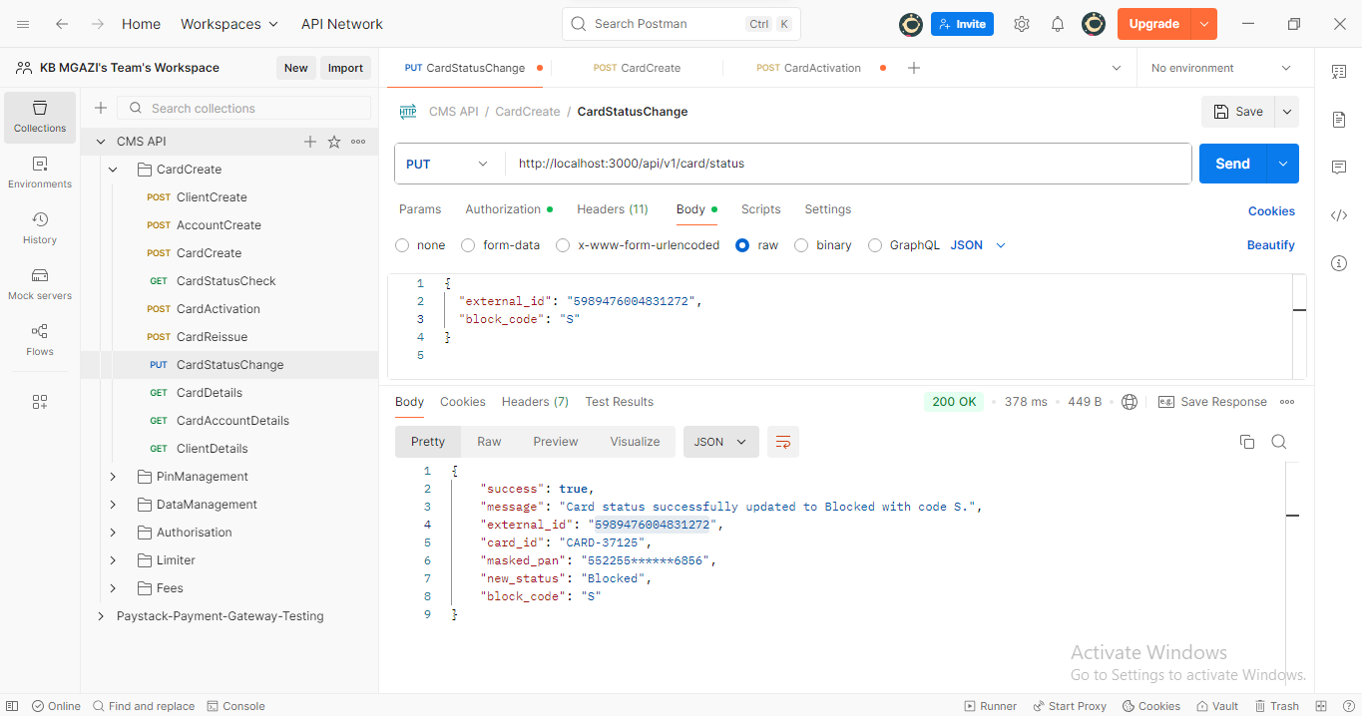
Request:
{
"external_id": "5989476004831272",
"block_code": "S"
}

Response:
{
"success": true,
"message": "Card status successfully updated to Blocked with code S.",
"external_id": "5989476004831272",
"card_id": "CARD-37125",
"masked_pan": "552255******6856",
"new_status": "Blocked",
"block_code": "S"
}

